Question 1

Question 2

Question 3

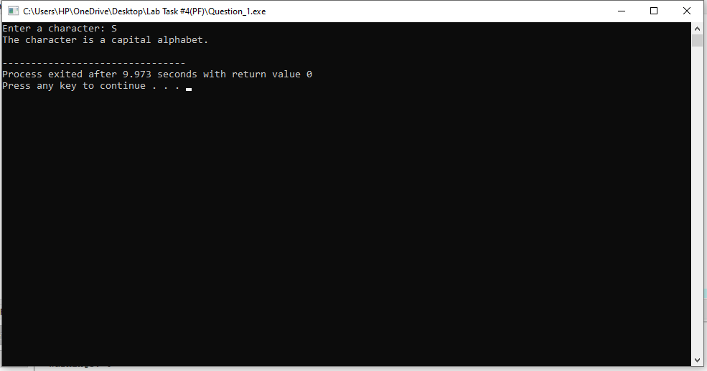

Question 4

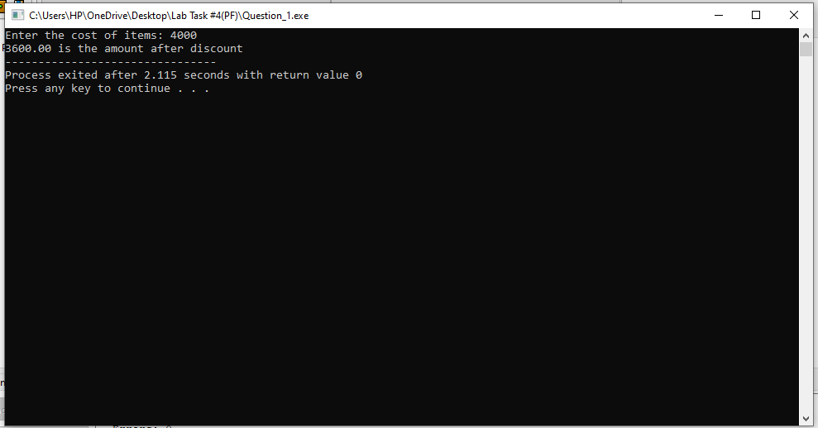

Question 5

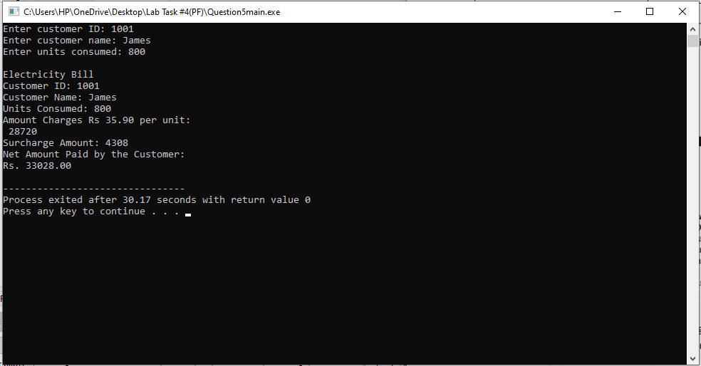

Question 6

Question 7

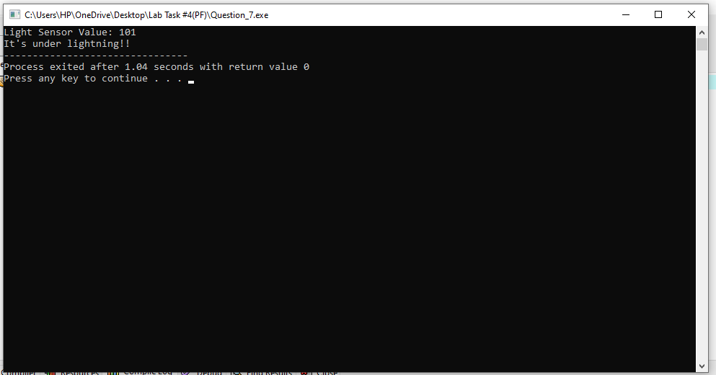

Question 8

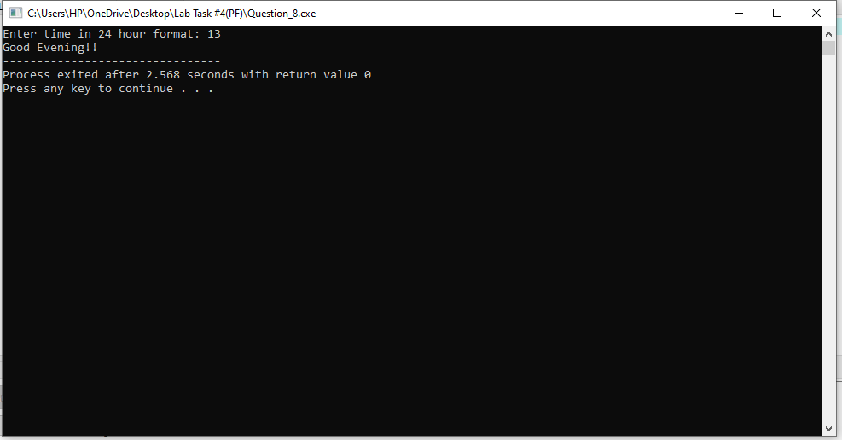

Question 9

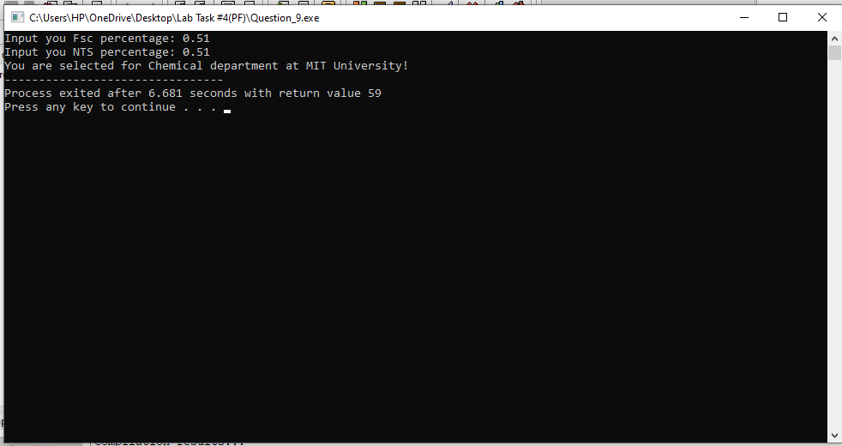

Question 10

